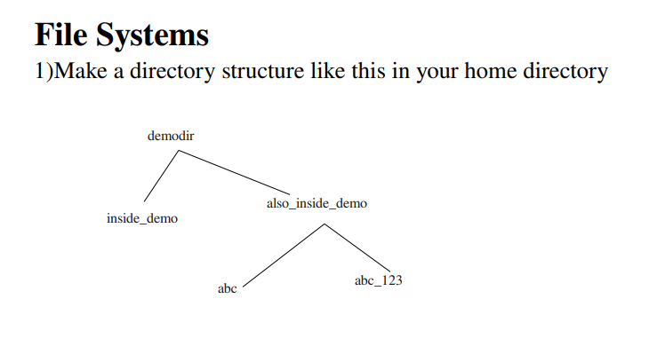
ANSWER:
mkdir <directoryname> -> to create directory with required name
cd <directoryname> ->to change directory
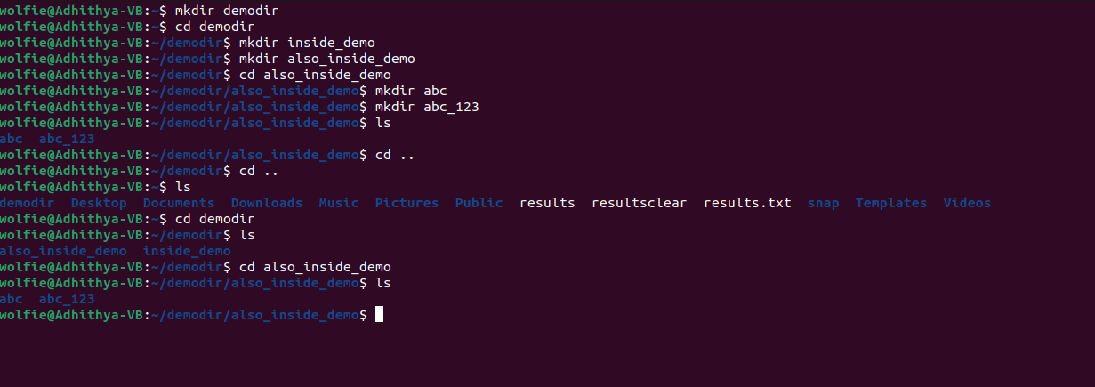

- Remove the also_inside_demo directory

ANSWER:
Directory must be empty to remove them.
Hence remove abc and abc_123 directories inside also_inside_demo

rmdir <directoryname> -> removes directory from memory .



